The basic Bellman-Ford algorithm is to relax the whole set of edges |V|-1 times. This is carried out in the |V|-1 iterations of the For loop. A more efficient version of the Bellman-Ford algorithm is to keep track of whether there is any changes to the d values in each iteration, and to stop when there is no change in one iteration. Implement this version by changing some codes of the basic Bellman-Ford algorithm and the relaxation routine.

Answer:
RELAX(u,v)
1 if v.d > u.d + w(u,v)
2 v.d = u.d + w(u,v)
3 v.pred = u
4 changes = true

Bellman-Ford Algorithm(G,s) /*G=(V,E)*/
1 INITIALIZE-SINGLE-SOURCE(G,s)
2 changes = true
3 Iterations_done=0;
4 while changes = true and Iterations_done<=|V|-1
5 change = false
6 for each edge (u,v) in E
7 RELAX(u,v)
8 Iterations_done++;
9 for each edge (u,v) in E
10 if v.d > u.d + w(u,v)
11 return false
12 return true

Run the Bellman-Ford algorithm on the following directed graph, using vertex z as the source.

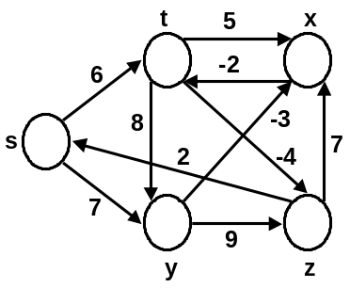

Answer:
